Invitation to Tender
Tender and Selection Questionnaire Information
Open Procedure

For the Provision of Maintenance Services Issued by

Guy's and St Thomas' NHS Foundation Trust for services at Royal Brompton and Harefield Hospitals
Reference Number: LGM33655
Tender Reference: 2021/S 000-024870

Maintenance Contract
Maintenance for domiciliary ventilators and associated equipment

Contents:
Glossary of Terms and Abbreviations 4
Introduction and Information 5
Purpose of this document 7
Lots 7
Verification of Information Provided 7
Instructions for return 7
Evaluation Process 9
Standstill Period 9
Selection Criteria 10
Methodology and Criteria 10
Part 1: Potential supplier information 10
Part 2: Exclusion grounds 10
Part 3: Selection Questions 11
Section 4 & 5 - Economic and financial standing 11
Section 6 – Technical and professional ability 11
Section 7 – Modern Slavery 11
Section 8 – Additional Questions 11
8.1 - Insurance 12
8.2 - Financial Capacity 12
8.3 - Turnover 13
8.4 - Quality Assurance 13
Award Criteria 14
Scoring methodology 14
A. Price criteria 14
B. Spare Parts Quality 15
C & D. Spare Parts Availability and Service Delivery 16
E. References 18
F. Clarification Stage 18
G. Presentations 18
Conditions for Tendering and Contract Requirements 19
Conditions for Tendering 19
TUPE 22
Sub-Contracting Arrangements 22
Consortium 23
Freedom of Information 23
Confidentiality 24

Glossary of Terms and Abbreviations
The following expressions shall have the following meaning:
“Bid” shall mean your response to this ITT and any associated documents, including completed Appendices
“Bidder “or “you/your” shall mean the suppliers that have been invited to tender
“the Contract” shall mean the contract which is awarded to the Contractor following this tender
“the Contractor” shall mean the successful Bidder
“the Equipment” shall mean all devices and equipment to be maintained and repaired
“the ITT” shall mean this Invitation to Tender
“the Services” shall mean those set out in the Technical Specification
“the Client” shall mean Guy’s and St Thomas’ NHS Foundation Trust – for services at Royal Brompton and Harefield Hospitals

Introduction and Information
The contract will be made up of the following documents:
- ITT Information document
- Technical Specification
- Selection Questionnaire
- ITT Response document
- Pricing Schedule – Appendix 1
- Appendices 2 - 12
You must read all documents related to this procurement.
Technical Specification
Accompanying this ITT information document is the Technical Specification which sets out the Client’s requirements. If you are not able to meet the Technical Specification you will be excluded from this procurement process.
Selection Questionnaire
The accompanying Selection Questionnaire (SQ) must be completed in full as this is for pre-qualification. Failure to do so will result in you being excluded from the procurement process.
Response document
The accompanying Tender Response document includes all questions relating to service delivery and spare parts quality and availability. You are required to complete all questions in all sections to avoid being excluded from the procurement process. The answers to these questions will be scored in line with the scoring methodology set out in this Information document.
You must complete all questions in the Invitation to Tender Response document. Any clarification questions should be submitted through the Lifecycle Tender Portal (OPTIMiSe) before 01/11/2021. The Client cannot guarantee they will be able to respond to a clarification question if it is received after this date. Please note an anonymised copy of the clarification questions together with the response will be sent to all potential Bidders.
Pricing Schedule
The accompanying Pricing Schedule includes the asset list with all current devices on contract, or in pool stock. You are required to complete tab ‘fixed price costs’ which will include all costs for PPM activity as per the accompanying Technical Specification. Please also complete tab ‘additional costs’ for all costs which fall outside the fixed price costs, including call out rates and commonly used spare parts for enhanced manufacturer recommendations. These costs will be charged in addition to the fixed price contract. The Pricing Schedule must be completed in full.
Your completed Invitation to Tender along with any requested supporting documentation must be submitted through OPTIMiSe by 2pm on 08/11/2021. The provisional timetable is detaile01/11/2021d below:
Task | Proposed Date
Advert Posted | 06/10/2021
Clarification Period ends | 01/11/2021
Deadline date and time for return of Invitation to Tender | 08/11/2021 at 2pm
Clarification meetings if required | Between 10/12/2021 & 28/01/2022
Feedback issued | 02/03/2022
Start date of contract | 01/04/2022

Due to exceptional circumstances, we reserve the right to extend the deadline for submission. This is at the discretion of the Client.

Purpose of this document
This Invitation to Tender (“ITT”) invites tenders for the maintenance of domiciliary ventilators and associated equipment It is issued by Guy’s and St Thomas’ NHS Foundation Trust for services to be provided for the –Royal Brompton and Harefield Hospitals (“the Client”) through its agent, Lifecycle Management Group Limited (“Lifecycle”), which is acting on the Client’s behalf in conducting this procurement exercise. A letter of authority from the Client is attached.
This ITT is issued to all suppliers that have expressed an interest following the publication of the Contract Notice, in connection with a competitive procurement conducted in accordance with the Open Procedure under the Public Contracts Regulations 2015
This ITT information document provides you with information about the procurement process and the evaluation and award criteria. You must complete the Tender Response Document and the Pricing Schedule and return both with your submission.

Lots
This contract will be awarded in a single lot.

Verification of Information Provided
Whilst reserving the right to request information at any time throughout the procurement process, the Client will require the supplier to self-certify there are no mandatory/ discretionary grounds for excluding their organisation. When requesting evidence, the supplier can meet the specified requirements (such as the questions in the selection questionnaire relating to Technical and Professional Ability) the Client will only obtain such evidence after the final tender evaluation decision i.e., from the highest scoring supplier only.

Instructions for return
You must complete and return all documents by the date stipulated. Failure to do so will result in your response not being assessed by the Client and being excluded from this process. Bids must be valid for at least 90 days.
All documents must be accessed via, and returned to, Lifecycle through Lifecycle’s online tendering portal.
You will have received a verification email account from OPTIMiSe asking you to verify your email address and create a password. These will be your log in details.
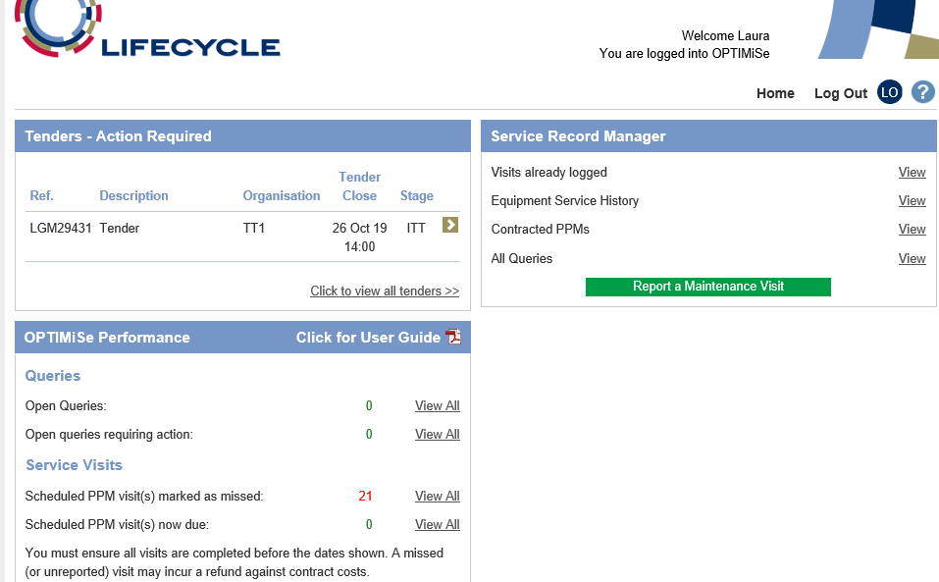
Once you have logged into the system you will be taken to your home screen where you can access the documents for the current tender.
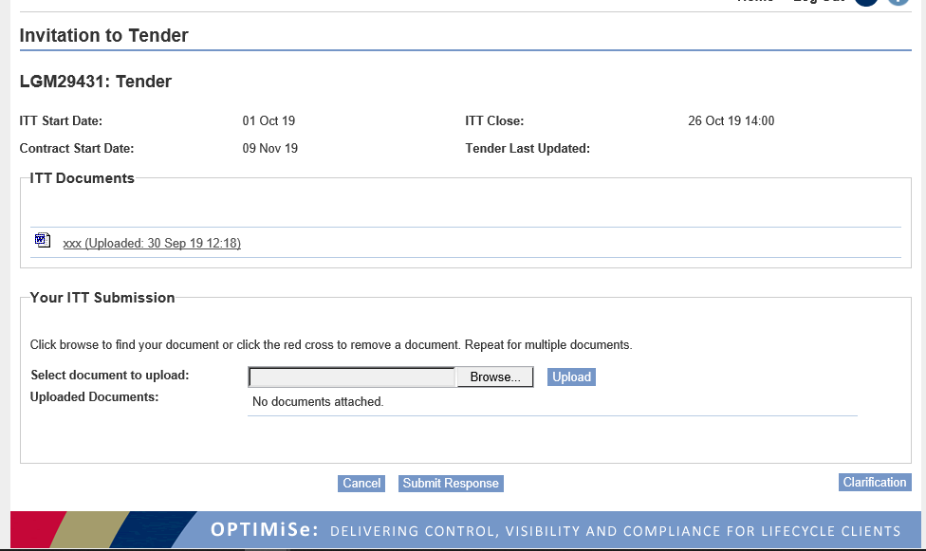
Within the “Tenders – Action Required” box, click on the green box with the white arrow next to the relevant tender, this will take you through to the page with all the relevant documents. An example of a tender page is shown below:
This screen will show the dates relevant to this procurement as well as all documents you need to complete your submission.
This is the portal you need to use to ask any clarification questions and upload your completed documents along with any supporting documents.
Click on each document and save them to your device for completion. All documents are version controlled. You must ensure you are using the latest version and upload any response against the latest version.
You must ensure you read and complete all documents thoroughly. When you have completed all documents, they must be uploaded to the portal together with any required attachments. To do this click the Browse button, find the document, and click Upload.
When you have uploaded all documents and attachments, you must click Submit Response or Amend Response.
All necessary documents must be completed and uploaded, together with attachments, to the portal before the close date and time.
NB: Please note you can submit your response and then amend this later up until the close date of the opportunity. Please ensure you click “Submit Response” or “Amend Response” before logging off, if you do not, anything you have uploaded will be lost. You will be evaluated against the version you have submitted.
If you do not receive an automated reply thanking you for your submission, please contact Lifecycle immediately.
PLEASE do not send any supporting documents unless requested to do so. Only documents requested will be reviewed by the Client.
Please see PDF document available in the OPTIMiSe tender portal “Embedding documents – completing your tender response” for guidance on how to embed documents into the Invitation to Tender document.
Your documents cannot be accessed until the deadline for return has passed. Ensure you have answered all questions contained in the ITT response document and selection questionnaire, completed, and signed the declaration and upload with any requested documents.

Evaluation Process
On receipt of Bids, the Client will perform an evaluation of the Bids with a view to selecting a Contractor to perform the Services. Details of the evaluation process and scoring methodology are set out below.

Standstill Period
The Client will exercise a standstill period in accordance with the requirements of the Public Contracts Regulations 2015.

Selection Criteria
This procurement process is being conducted in accordance with the Open Procedure. However, you need to meet a selection of minimum requirements (Selection Criteria) before the Client will score and evaluate your Bid. You are required to complete the Selection Questionnaire. If you do not meet one or more of the minimum requirements for each Selection Criteria, you will be excluded from this procurement process. If you pass all Selection Criteria, your Bid will be scored and evaluated.

Methodology and Criteria
This section sets out the criteria the Client will use to evaluate your submission in the Selection Questionnaire.
You must pass all eligibility questions in the Selection Questionnaire (Part 2 – Sections 2 and 3).
Reference | Selection Criteria | Weightings
Part 2 – Section 2 | Grounds for mandatory exclusion | Pass/Fail
Part 2 – Section 3 | Grounds for discretionary exclusion | Pass/Fail
Part 3 – Section 4 & 5 | Economic and financial standing | Pass/Fail
Part 3 – Section 6 | Technical and professional ability | Pass/Fail
Part 3 – Section 7 | Modern Slavery Act | Pass/Fail
Part 3 – Section 8.1 | Insurance | Pass/Fail
Part 3 – Section 8.2 | Financial capacity | Pass/Fail
Part 3 – Section 8.3 | Turnover | Pass/Fail
Part 3 – Section 8.4 | Quality Assurance | Pass/Fail

Part 1: Potential supplier information
This is for information only and will not be scored.

Part 2: Exclusion grounds
Note every organisation which is being relied on to meet the selection criteria must complete and submit Part 1 and Part 2 self-declarations.
You will be excluded from the procurement process if there is evidence of convictions relating to specific criminal offences including, but not limited to, bribery, corruption, conspiracy, terrorism, fraud, and money laundering, or if you have been the subject of a binding legal decision which found a breach of legal obligations to pay tax or social security obligations (except where this is disproportionate e.g., only minor amounts involved).
The Client may exclude any Supplier which answers ‘Yes’ in any of the situations set out in Section 3 – Grounds for discretionary exclusion.

Part 3: Selection Questions

Section 4 & 5 - Economic and financial standing
If requested, please provide a copy of your audited accounts for the last two years. If you are unable to provide two years audited accounts or one of the other alternative forms of financial status, you will be excluded from the procurement process.

Section 6 – Technical and professional ability
In this section, the Client is assessing your relevant experience. Your answers will be scored as follows:
Evaluation | Description | Pass/Fail
Proven Ability | You have provided evidence of your Technical and Professional Ability to deliver similar type of contracts | Pass
No Ability | You have provided limited or no evidence of your Technical and Professional Ability to deliver similar type of contracts. | Fail

When assessing this section, the Client will consider performance on previous contracts of a similar type for the Client over the past three years. The Client will not however take into its own positive experience on previous contracts, or positive experience of other Clients or public bodies, other than the examples and information provided by you.
You should not use any examples of contracts you hold with the Client.

Section 7 – Modern Slavery
You are required to provide the information as requested under the Modern Slavery Act. If you do not provide an adequate response, you will fail this section.

Section 8 – Additional Questions
You are not required to provide supporting information for this section. If you self-certify you meet the requirements, you will be required to provide evidence if you are successful at contract award stage.

8.1 - Insurance
You are required to have specific insurances, which are set out later in the Selection Questionnaire. If you do not have all of these, you will be excluded from the procurement process.
Copies of certificates are not required at this stage. The Client may request the winning bidder to provide copies of these certificates on award of contract.

8.2 - Financial Capacity
This section is to determine whether you have the financial capacity and stability to perform the service.
Credit Score:
You are asked to provide your organisation’s registration number so a Credit Report (from Company Searches Made Simple) can be obtained. If the Creditworthiness rating (for companies where accounts have been filed) or Risk rating (for new companies where no accounts have been filed) is less than 50 your financial accounts or equivalent information will be considered.
If the rating in the Report is more than 50 you will pass this section unless there is anything in the report to indicate, you may not have the financial capacity to perform this contract. In this case the Client will evaluate your financial accounts or equivalent information.
If you do not have a registration number, for example you are a partnership, you should provide the last two years’ audited accounts, or equivalent information as set out in the Financial Capacity questions in the Selection Questionnaire.
If the Client evaluates the financial accounts or equivalent information, they will be scored according to the table below. Evaluation will include consideration of evidence of prior bankruptcy or a CVA, accounts being up to date, any qualification of the accounts by auditors, a general review of accounts, a review of profit and loss from previous years, a review of the balance sheet.
Accounts will be scored according to the table below:

Evaluation | Standard | Pass/Fail
No risk | The bidder has met the financial criteria set out in the ITT. | Pass
Unacceptable risk | The bidder has not met the financial criteria set out in the ITT. | Fail

8.3 - Turnover
You are asked to provide details of your annual turnover for the past three years within the business division for the service you are tendering. Your total contract bid should make up no more than 50% of your average annual turnover. You may be asked to provide evidence if you are the successful bidder.
For example, if your total contract bid is £20,000.00, you must have a minimum annual turnover of £40,000.00.
If you do not have the required turnover, you will fail this element. If you fail either of the two financial capacity criteria requirements you will be excluded from the procurement process.

8.4 - Quality Assurance
You are required to have ISO 9001 accreditation. If you do not have this accreditation, you will be excluded from the procurement process. If you are working towards this accreditation, it must be in place before contract award.

Award Criteria

Scoring methodology
If you pass the Selection Criteria above, the Client will select the Most Economically Advantageous Tender (MEAT) according to the methodology indicated in the table below. Some criteria have been allocated a weighting and these weightings equal 100%: Some others are assessed as PASS/FAIL. If you FAIL one of the criteria indicated in the table, you will be excluded from the procurement process.
 | Description | Weighting % | Definition
A | Price | 20% | Fixed price costs
 |  | 20% | Additional costs
B | Spare Parts Quality | PASS/FAIL | Assessment of the quality of the spare parts. If they are not OEM, an assessment of whether they are equivalent or better in quality, compatibility, and warranty than OEM parts.
C | Spare Parts Availability | 5% | Assessment of the availability of spare parts and where they are held.
D | Service Delivery | 55% | Assessment of the Client’s confidence you will be able to fulfil the Technical Specification.

The Bidder with the highest overall score once weightings have been applied will be selected as the Contractor.

Price criteria
The Contract will be awarded on a fixed price basis with additional costs charged for service kits, batteries, and consumables. Price will therefore be made up of the following two components:
Price component | Description
Fixed PPM Contract price | The annual price offered for the fixed Contract.
Additional costs | The Client has created a scenario based on the anticipated quantity of spare parts required during an average year, the number of service kits and battery replacements. You must provide a price for each of these based on the clients anticipated usage. You are required to provide pricing for different elements of additional costs, such as call-out rates and hourly labour rates.  This information is for evaluation purposes only and not guaranteed business. A total of all additional costs will be calculated in line with the methodology set out in this document.

The Client will evaluate your fixed contract price and your additional costs separately. The following scoring methodology will then be used:
The Bidder with the lowest cost for each price criterion (contract costs and ad-hoc costs) will receive full marks.

Other bidders’ prices will be awarded marks by application of the following formula:

(Lowest overall price/Overall price being evaluated) x price weighting = price score.
For example, Bidder A submits a price of £1,000.00, Supplier B submits £1,250.00 and Supplier C submits £1,600.00, against a price weighting of 50%.
Supplier A will receive the full 50%, Supplier B receives 40%, and Supplier C receives 31.25%.
All bids will be scored in this manner.

B. Spare Parts Quality
The Client needs to ensure the spare parts which will be used are of sufficient quality and compatibility for the Equipment. The Client will do this by accepting either Original Equipment Manufacturer (OEM) parts or non-OEM, used or refurbished parts which are demonstrably equivalent or better than OEM parts. You are asked to confirm whether you intend to use OEM or non-OEM, used or refurbished parts.
If you intend to use anything other than new OEM parts you are asked to demonstrate the parts used are equivalent or better quality, compatibility, and warranty.
In the event the Client does not consider the proposed non-OEM, used or refurbished parts are equivalent or better in quality, compatibility, and warranty than OEM parts, you will be excluded from this procurement process.
Evaluation | Description | Pass/Fail
New OEM parts used only | You have confirmed you will only use new OEM parts | Pass
Equivalent parts | You have provided sufficient evidence that the proposed non-OEM, used or refurbished parts are equivalent or better in quality, compatibility, and warranty than OEM parts. | Pass
Non-equivalent parts | You have not provided sufficient evidence that the proposed non-OEM, used, or refurbished parts are equivalent or better in quality, compatibility, and warranty than OEM parts. | Fail

C & D. Spare Parts Availability and Service Delivery
In submitting a Bid, you have committed to delivering the service in line with the accompanying Technical Specification. If you are unable to meet the Technical Specification you will be excluded from this procurement process.

Your responses to the questions detailed in the Bidder Response Document will be evaluated and scored as follows:

Some questions may be more critical than others. Some questions are pass/fail, some are weighted. You will be excluded from this procurement process if you fail any of the pass/fail questions below.
Some questions will be weighted between 1 and 5, with 5 being the highest significance and 1 being the lowest significance. Your responses will be scored between 0 and 4 as per the table below. If you score 0 for a question you will be excluded from the process.
If a question is weighted 5 (as it is considered the highest significance), and you have provided a fully compliant response, the Client will score that question 4, resulting in a total score of 20 (5 x 4 = 20). If the question is weighted 5 and you have provided only a partially acceptable response, , the Client will score you 2, resulting in a total score of 10 (5 x 2 = 10).
The score given per question will then be added together for each section and a total score provided. For example, if there are 16 questions for service delivery and each question is weighted 5, a total of 320 marks will be available (16 x 5 x 4).
In summary, therefore, all Bids will be scored proportionately in this manner using the following scoring scale to evaluate the answer given to each question. If you score maximum marks for all questions, you will be allocated the maximum % weighting available. If you score half of the total marks available, you will receive 50% of the weighting available. All scores will be converted in this manner.
Scoring Scale for Spare Parts Availability Question C.1

Score | Standard
Pass | You have confirmed you will have the required spare parts to maintain and repair the Equipment detailed in the Contract.
Fail | You have not confirmed you will have the required spare parts to maintain and repair the Equipment detailed in the Contract.

Scoring Scale for Service Delivery Question D.1

Score | Standard
Pass | You have answered yes to this question with no variance to the Technical Specification
Fail | You have answered no to this question or offered a variant bid

Scoring Scale for Service Delivery Question D.2

Score | Standard
Pass | The Client is confident you have provided a realistic and detailed implementation plan which will ensure the contract will commence on time.
Fail | The Client is not confident you have a comprehensive implementation plan in place to ensure the contract will commence on time.

Scoring Scale for Spare Parts Availability Questions C.2 – C.6 and Service Delivery Questions D.3 – D.23
Score | Classification | Definition
0 | No response  (non-compliance) | You have not answered the question, or your response is non-compliant and does not give the client confidence you can perform the required service. You will be excluded from this procurement process.
1 | Unsatisfactory response | Substantially unacceptable submission which fails in several significant areas to answer the question.  Little or no detail (and, where evidence is required or necessary, no evidence) has been provided to support and demonstrate you are able to provide the service required, or specifically show relevant ability, understanding, expertise, skills and/or resources.  Would represent a very high risk for the Client.
2 | Partially acceptable response | Weak submission which does not fully address the question.  Response may be basic/minimal with little or insufficient detail (and, or insufficient breadth where evidence is required or necessary, insufficient evidence) provided to support the submission and demonstrate you have the required capability and capacity to deliver the requirements of the Technical Specification.
3 | Satisfactory and acceptable response | Submission largely addresses and meets all requirements, with some detail (or, where evidence is required or necessary, some evidence is relevant) provided to support the submission.  There are some minor reservations or weaknesses in the submission and not all requirements were supported by strong evidence.
4 | Fully compliant response | Submission sets out a comprehensive and robust response which addresses and meets all requirements, with strong evidence provided to support the submission. Submission clearly demonstrates the supplier’s capability, expertise and capacity to deliver the requirements of the Technical Specification.

E. References
Bidders are asked to provide details of three references relevant to the contract. The Client reserves the right to contact the references and verify the information provided. References will not be scored as an independent section.

F. Clarification Stage
The Client reserves the right to ask additional clarification questions during the evaluation stage. All clarifications will be made in writing.

G. Presentations
The Client reserves the right to ask you to present your bid during the evaluation process. The Client may use the information obtained to verify draft scores given to your responses.

Conditions for Tendering and Contract Requirements

Conditions for Tendering
- This ITT is intended for the organisation to which it has been sent. Receipt of a Bid from your organisation will be deemed to have been “signed” by the individual named at the end of the Declaration.
- Please answer all questions. Failure to do so may result in you being excluded from this tender process.
- Questions should be answered in English.
- If any of the questions do not apply to your organisation, please mark them as N/A. If you do not know the answer, please mark as ‘Not Known’, but this may result in no score being awarded for that question, or exclusion from the process if it is a Pass/Fail question.
- Except for answering the questions in the spaces provided, no alteration may be made in this document or the accompanying documents. If any alteration is made, or if the terms and conditions of the ITT are not fully complied with, your Bid may be rejected.
- You must complete and return your submission by the date and time stipulated in this document.
- You are required to complete and return the Declaration at the end of the ITT. The Declaration includes statements in relation to the Form of Bid, Collusive Tendering and Canvassing.
- The Client reserves the right to disqualify you if you do not submit your Bid in a manner consistent with the provisions set out in the ITT.
- In submitting a Bid, you will be deemed to have accepted all the provisions of the ITT including these conditions.
- Bids must be submitted for the provision of the Services based on the Terms and Conditions of this ITT document.
- An express waiver or variation of any of these Conditions made in writing by a Director or Head of Procurement for the Client shall bind the Client, otherwise, no other officer of the Client or Associate has the right to vary or waive any of these Conditions.
- If any obvious mistakes come to the Client’s attention when evaluating your Bid, the Client may notify you and provide you with an opportunity to correct your error. This does not place any obligation on the Client to identify errors within your Bid.
- The Client is not bound to accept the lowest or any Bid, nor will it be responsible for, or pay any expenses or losses which may be incurred by you in the preparation and completion of your Bid. If a tender is accepted, written notification will be sent to you.
- By issuing this ITT the Client is not bound in any way to enter any contractual or other arrangement with you or any other party.
- The Client reserves the right to accept a Tender either in whole or in part and no one part of the offer is dependent on any other part unless you stipulate to the contrary.
- During the Bid evaluation stage, the Client may request written clarification from you on your Bid. Any request for clarification on Bids shall be made in writing to the named person within this document. Your response will normally be required by email and within two business days of request.
Failure to respond adequately or within the deadline will be reflected in the evaluation of the Bid and may result in your exclusion from this procurement process.
The Client reserves the right to request a meeting with you during the ITT Bid evaluation stage to facilitate a rapid clarification of points raised.
- The Client reserves the right to publish details of the contract which is awarded on Contracts Finder, including the name of the Contractor and total value of the contract.
- Following the appointment of the Contractor, in the event the Contractor:
  - Makes a material alteration to the Bid which formed the basis of its selection.
  - Does not comply with the provisions of this ITT.
  - In the reasonable opinion of the Client fails to make satisfactory progress towards signature of the Contract.
And fails to remedy the situation to the reasonable satisfaction of the Client within a defined time, the Client shall be entitled to de-select the Contractor. Under no circumstance will the Client, Lifecycle or any other agent be liable for any costs or expenses incurred by the Contractor due to, or arising from, such de-selection.
- The information contained in this ITT and supporting documents and in any related written or oral communication are believed to be correct at the time of issue, but the Client will not accept any liability for its accuracy, adequacy or completeness and no warranty is given as such. This exclusion does not extend to any fraudulent misrepresentation made by or on behalf of the Client. Information supplied to you by the Client, Lifecycle or any other agents is supplied to the Bidder only for general guidance in the preparation of his Bid. You MUST satisfy by your own investigations, the accuracy of any such information, and no responsibility is accepted by the Client, Lifecycle or any other agent for any loss or damage of whatever kind and howsoever caused arising from the use by you of any such information.
- You will not be entitled to claim from the Client any cost or expenses you may incur in preparing your Bid irrespective of whether your Bid is successful. You must obtain at your own expense all information necessary for the preparation of your tender.
- All information supplied by the Client, either in writing or orally, must be treated in confidence and not disclosed to any third party (save to your professional advisers) unless the information is already in the public domain. All the information supplied by the Client, Lifecycle or any other agents in connection with this ITT shall be regarded as confidential to the Client and by submitting a tender you agree to be bound by the obligation to preserve the confidentiality of the documents.
- By downloading or responding to any part of this tender you are confirming your compliance with the new General Data Protection Regulation (GDPR) and will treat any personally identifiable information received during the process in accordance with the GDPR.
- The ITT and associated documents are and shall remain the property of the Client and must be returned on demand.
- There must be no publicity by you regarding the Services or the future award of any Contract unless the Client has given express written consent to the relevant communication.
- It is your responsibility to ensure any consortium member, sub-contractor or adviser abides by the terms set out in this ITT.
- Any attempt by you or your appointed advisers to inappropriately influence the Contract award process in any way will result in your Bid being disqualified. Any direct or indirect canvassing by you or your appointed advisers in relation to this procurement or any attempt to obtain information from any of the employees or agents of the Client concerning another tendering organisation may result in disqualification at the discretion of the Client.
- The Client reserves the right to:
- Cancel the selection and evaluation process at any stage.
- Ask you to clarify your submission in writing and/or provide additional information.
- Amend the terms and conditions of the tender process.
- Where information or documentation submitted by you is, or appears to be incomplete or erroneous, or where specific documents are missing, the Client may request you to submit, supplement, clarify or complete the relevant information or documentation within an appropriate time limit, provided that such requests are made in full compliance with the principles of equal treatment and transparency.
- You should be aware that any contracts arising from this procurement process are subject to the NHS Conditions for the Provision of Services with Maintenance Schedule. A copy can be obtained from:
https://www.lifecycle.co.uk/contracts/NHS_Terms_and_Conditions_For_The_Provision_of_Services_with_Maintenance_Schedule_Nov_2018.pdf

TUPE
Transfer of Undertakings (Protection of Employment) Regulations 2006 TUPE

Your attention is drawn to the Transfer of Undertakings (Protection of Employment) Regulations 2006 (TUPE). As the Client would be neither the transferor nor transferee of the staff in the circumstances of any contract awarded because of this Invitation to Tender, consideration of the application of TUPE in this case is not a matter of direct concern to the Client. Nevertheless, you may wish to note that it is the Client’s view that TUPE is likely to apply. It is your responsibility, however, to consider whether TUPE applies in the specific circumstances of your bid particularly if you are proposing to submit an innovative bid, and to tender accordingly.

If you have a contrary view to that of the Client on the applicability of TUPE, it would be helpful if you would advise the Client giving your reasons, prior to the tender return date. If any transfer resulting from this constitutes a transfer of an undertaking under TUPE those elements of the Contract documents relating to TUPE will apply.

Information to enable you to formulate your bid on the basis that TUPE applies is set out in Appendix 12 This information must be treated on a confidential basis and is released to you on the understanding you will not copy or use the material except for the purposes of preparing your bid and you will return it and any copies of it should you be unsuccessful in this competition.

The TUPE information detailed in Appendix 12 has been obtained from the contractor currently undertaking this task. Whilst the Client has obtained this information in good faith the Client gives no guarantee or assurance as to the accuracy of this information and cannot be held responsible for errors or omissions in it. It remains your responsibility to ensure that your tender takes full account of all the relevant circumstances.

Sub-Contracting Arrangements
If you propose to use one or more sub-contractors to deliver some or all the contract requirements, a separate Appendix should be used to provide details of the proposed bidding model which includes members of the supply chain, the percentage of work being delivered by each sub-contractor and the services each sub-contractor will be responsible for.

The Client recognises arrangements for sub-contracting may be subject to future change and may not be finalised until a later date. However, you should be aware that where information provided to the Client indicates sub-contractors are to play a significant role in delivering key contract requirements, any changes to those sub-contracting arrangements may affect your ability to proceed with the procurement process or to provide the supplies and/or services required. You should notify the Client immediately of any change in the proposed sub-contractor arrangements. The Client reserves the right to deselect the Supplier prior to any award of contract, based on an assessment of the updated information.

Consortium
If you are completing the ITT Response Document as part of a proposed consortium, the following information must be provided.
- names of all consortium members.
- the lead member of the consortium who will be contractually responsible for delivery of the contract (if a separate legal entity is not being created); and
- if the consortium is not proposing to form a legal entity, full details of proposed arrangements within a separate Appendix.
The Client may require the consortium to assume a specific legal form if awarded the contract. This is deemed by the Client as being necessary for the satisfactory performance of the contract.
All members of each consortium will be required to complete all sections of the ITT.
If you are proposing to create a separate legal entity, such a Special Purpose Vehicle (SPV), you should provide details of the actual or proposed percentage shareholding of the constituent members within the new legal entity in a separate Appendix.
The Client recognises arrangements in relation to a consortium bid may be subject to future change. You should therefore respond based on the arrangements as currently envisaged. You are reminded the Client must be immediately notified of any changes or proposed changes, in relation to the bidding model so a further assessment can be carried out by applying the selection criteria to the new information provided. The Client reserves the right to deselect the Supplier prior to any award of contract, based on an assessment of the updated information.

Freedom of Information
In accordance with the obligations and duties placed upon public authorities by the Freedom of Information Act 2000 (the FoIA) all information submitted to the Client may be disclosed in response to a request made pursuant to the FoIA.
In respect of any information submitted you consider commercially sensitive you should:
- Clearly identify such information as commercially sensitive
- Explain the potential implications of disclosure of such information and
- Provide an estimate of the period you believe such information will remain commercially sensitive
Where you identify information as commercially sensitive the Client will endeavour to maintain confidentiality. Where information is identified as commercially sensitive, the Client may be required to disclose such information in accordance with the FoIA. Accordingly, the Client cannot guarantee any information marked commercially sensitive will not be disclosed.

Confidentiality
When providing details of contracts in the Reference section ITT (Technical and Professional Ability), you agree to waive any contractual or other confidentiality rights and obligations associated with these contracts.
The Client reserves the right to contact the named customer contacts in the References section regarding the contracts listed. The named customer contact does not owe the Client any duty of care or have any legal liability, except for any deceitful or maliciously false statements of fact.
The Client confirms it will keep all information confidential and will not disclose to any third parties, other than to the Crown Commercial Service and/or contracting authorities defined by the Public Contracts Regulations.

